**BÁO CÁO THỰC HÀNH KIẾN TRÚC MÁY TÍNH TUẦN 10 (P2)**

**Assignment 1**

* **Vẽ tam giác:**
* Code

.eqv HEADING 0xffff8010 # Integer: Goc quay tu 0 den 359

# 0 : Tren

# 90: Phai

# 180: Duoi

# 270: Trai

.eqv MOVING 0xffff8050 # Boolean: Co di chuyen hay khong

.eqv LEAVETRACK 0xffff8020 # Boolean (0 hoac !0):

# Co track hay khong

.eqv WHEREX 0xffff8030 # Integer: Doc gia tri X hien tai cua con bot

.eqv WHEREY 0xffff8040 # Integer: Doc gia tri Y hien tai cua con bot

.text

main:

addi $a0, $0, 90 # Quay sang trai de bat dau chay

jal ROTATE

jal GO

sleep0:

addi $v0, $zero, 32 # De no chay trong 3000ms

li $a0, 3000

syscall

jal STOP

jal TRACK # Danh dau dia diem hien tai de bat dau ve canh 1

addi $a0, $0, 150 # Quay goc 150

jal ROTATE

jal GO

sleep1:

addi $v0, $zero, 32 # De no chay trong 3000ms

li $a0, 3000

syscall

jal UNTRACK # Ve duong thang tu diem hien tai toi TRACK cu

jal TRACK # Danh dau TRACK de bat dau ve canh 2

addi $a0, $0, 30 # Quay goc 30

jal ROTATE

jal GO

sleep2:

addi $v0, $zero, 32 # De no chay trong 2990ms

li $a0, 2990 # cho bot chay gan den goc do thi dung

syscall

jal UNTRACK # Ve duong thang tu diem hien tai toi TRACK cu

jal TRACK # Danh dau TRACK

addi $a0, $0, 270 # Quay goc

jal ROTATE

jal GO

sleep3:

addi $v0, $zero, 32 # De no chay trong 3000ms

li $a0, 3000

syscall

jal UNTRACK # Ve duong thang tu diem hien tai toi TRACK cu

#jal TRACK # Danh dau TRACK

jal STOP

endmain:

li $v0, 10

syscall

GO:

li $at, MOVING # Thay doi cong MOVING

addi $k0, $0, 1 # logic 1

sb $k0, ($at) # Bat dau chay

jr $ra

STOP:

li $at, MOVING # Thay doi cong MOVING

sb $0, ($at) # Dung chay

jr $ra

TRACK:

li $at, LEAVETRACK # Thay doi cong LEAVETRACK

addi $k0, $0, 1 # logic 1

sb $k0, 0($at) # bat dau tracking

jr $ra

UNTRACK:

li $at, LEAVETRACK # Thay doi cong LEAVETRACK

sb $0, 0($at) # dung ve

jr $ra

ROTATE:

li $at, HEADING # Thay doi cong HEAD

sw $a0, ($at) # Xoay robot

jr $ra

* Kết quả:

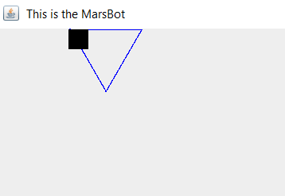

* **Vẽ hình vuông:**
* Code:

.eqv HEADING 0xffff8010 # Integer: Goc quay tu 0 den 359

# 0 : Tren

# 90: Phai

# 180: Duoi

# 270: Trai

.eqv MOVING 0xffff8050 # Boolean: Co di chuyen hay khong

.eqv LEAVETRACK 0xffff8020 # Boolean (0 hoac !0):

# Co track hay khong

.eqv WHEREX 0xffff8030 # Integer: Doc gia tri X hien tai cua con bot

.eqv WHEREY 0xffff8040 # Integer: Doc gia tri Y hien tai cua con bot

.text

main:

addi $a0, $0, 90 # Quay sang trai de bat dau chay

jal ROTATE

jal GO

sleep0:

addi $v0, $zero, 32 # De no chay trong 3000ms

li $a0, 3000

syscall

jal STOP

jal TRACK # Danh dau TRACK

addi $a0, $0, 180 # Quay goc

jal ROTATE

jal GO

sleep2:

addi $v0, $zero, 32 # De no chay trong 3000ms

li $a0, 3000

syscall

jal UNTRACK # Ve duong thang tu diem hien tai toi TRACK cu

jal TRACK # Danh dau TRACK

addi $a0, $0, 90 # Quay goc

jal ROTATE

jal GO

sleep3:

addi $v0, $zero, 32 # De no chay trong 3000ms

li $a0, 3000

syscall

jal UNTRACK # Ve duong thang tu diem hien tai toi TRACK cu

jal TRACK # Danh dau TRACK

addi $a0, $0, 0 # Quay goc

jal ROTATE

jal GO

sleep4:

addi $v0, $zero, 32 # De no chay trong 3000ms

li $a0, 2980

syscall

jal UNTRACK # Ve duong thang tu diem hien tai toi TRACK cu

jal TRACK # Danh dau dia diem hien tai

addi $a0, $0, 270 # Quay sang trai de bat dau chay

jal ROTATE

jal GO

sleep1:

addi $v0, $zero, 32 # De no chay trong 3000ms

li $a0, 3000

syscall

jal UNTRACK # Ve duong thang tu diem hien tai toi TRACK cu

jal STOP

endmain:

li $v0, 10

syscall

GO:

li $at, MOVING # Thay doi cong MOVING

addi $k0, $0, 1 # logic 1

sb $k0, ($at) # Bat dau chay

jr $ra

STOP:

li $at, MOVING # Thay doi cong MOVING

sb $0, ($at) # Dung chay

jr $ra

TRACK:

li $at, LEAVETRACK # Thay doi cong LEAVETRACK

addi $k0, $0, 1 # logic 1

sb $k0, 0($at) # bat dau tracking

jr $ra

UNTRACK:

li $at, LEAVETRACK # Thay doi cong LEAVETRACK

sb $0, 0($at) # dung ve

jr $ra

ROTATE:

li $at, HEADING # Thay doi cong HEAD

sw $a0, ($at) # Xoay robot

jr $ra

* Kết quả:

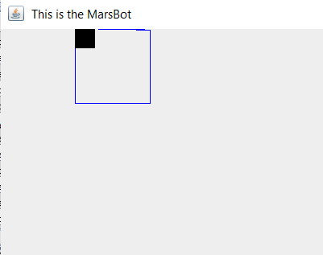

* **Vẽ hình sao:**
* Code:

.eqv HEADING 0xffff8010 # Integer: Goc quay tu 0 den 359

# 0 : Tren

# 90: Phai

# 180: Duoi

# 270: Trai

.eqv MOVING 0xffff8050 # Boolean: Co di chuyen hay khong

.eqv LEAVETRACK 0xffff8020 # Boolean (0 hoac !0):

# Co track hay khong

.eqv WHEREX 0xffff8030 # Integer: Doc gia tri X hien tai cua con bot

.eqv WHEREY 0xffff8040 # Integer: Doc gia tri Y hien tai cua con bot

.text

main:

addi $a0, $0, 90 # Quay sang trai de bat dau chay

jal ROTATE

jal GO

sleep0:

addi $v0, $zero, 32 # De no chay trong 3000ms

li $a0, 5000

syscall

jal STOP

jal TRACK # Danh dau dia diem hien tai

addi $a0, $0, 162 # Quay sang trai de bat dau chay

jal ROTATE

jal GO

sleep1:

addi $v0, $zero, 32 # De no chay trong 3000ms

li $a0, 6000

syscall

jal UNTRACK # Ve duong thang tu diem hien tai toi TRACK cu

jal TRACK # Danh dau TRACK

addi $a0, $0, 306 # Quay goc

jal ROTATE

sleep2:

addi $v0, $zero, 32 # De no chay trong 3000ms

li $a0,6000

syscall

jal UNTRACK # Ve duong thang tu diem hien tai toi TRACK cu

jal TRACK # Danh dau TRACK

addi $a0, $0, 90 # Quay goc

jal ROTATE

sleep3:

addi $v0, $zero, 32 # De no chay trong 3000ms

li $a0, 6000

syscall

jal UNTRACK # Ve duong thang tu diem hien tai toi TRACK cu

jal TRACK # Danh dau TRACK

addi $a0, $0, 234 # Quay goc

jal ROTATE

sleep4:

addi $v0, $zero, 32 # De no chay trong 3000ms

li $a0, 6000

syscall

jal UNTRACK # Ve duong thang tu diem hien tai toi TRACK cu

jal TRACK # Danh dau TRACK

addi $a0, $0, 18 # Quay goc

jal ROTATE

sleep5:

addi $v0, $zero, 32 # De no chay trong 3000ms

li $a0, 6000

syscall

jal UNTRACK # Ve duong thang tu diem hien tai toi TRACK cu

jal STOP

endmain:

li $v0, 10

syscall

GO:

li $at, MOVING # Thay doi cong MOVING

addi $k0, $0, 1 # logic 1

sb $k0, ($at) # Bat dau chay

jr $ra

STOP:

li $at, MOVING # Thay doi cong MOVING

sb $0, ($at) # Dung chay

jr $ra

TRACK:

li $at, LEAVETRACK # Thay doi cong LEAVETRACK

addi $k0, $0, 1 # logic 1

sb $k0, 0($at) # bat dau tracking

jr $ra

UNTRACK:

li $at, LEAVETRACK # Thay doi cong LEAVETRACK

sb $0, 0($at) # dung ve

jr $ra

ROTATE:

li $at, HEADING # Thay doi cong HEAD

sw $a0, ($at) # Xoay robot

jr $ra

* Kết quả:

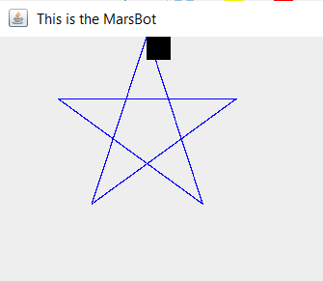

**Assignment 2**

* **Code:**

.eqv KEY_CODE 0xffff0004 # ASCII tu ban phim, 1 byte

.eqv KEY_READY 0xffff0000 # =1 neu ma co ky tu moi

# tu dong clear sau lw

.eqv DISPLAY_CODE 0xffff000c # ASCII de show, 1 byte

.eqv DISPLAY_READY 0xffff0008 # = 1 neu ma san sang ghi, clear sau sw

.text

li $k0, KEY_CODE

li $k1, KEY_READY

li $s0, DISPLAY_CODE

li $s1, DISPLAY_READY

li $s2, 64

li $s3, 91

li $s4, 96

li $s5, 123

li $t5, 1

li $t6, 2

li $t7, 3

li $t8, 47

li $t9, 58

li $s7, 0

loop:

nop

WaitForKey:

lw $t1, ($k1) # t1 = [k1] = KEY_READY

beq $t1, $0, WaitForKey # key == 0 => wait

ReadKey:

lw $t0, ($k0) # Doc ky tu

WaitForDis:

lw $t2, ($s1)

beq $t2, $0, WaitForDis

ToLower:

sgt $t2, $t0, $s2 # if t0 >= 65 && t0 <= 90

slt $t3, $t0, $s3

and $t4, $t2, $t3

beqz $t4, ToUpper # If true => toupper

addi $t0, $t0, 32

j ShowKey

ToUpper:

sgt $t2, $t0, $s4 # if t0 >= 96 && t0 <= 123

slt $t3, $t0, $s5

and $t4, $t2, $t3

beqz $t4, Number # If true => number

subi $t0, $t0, 32

j ShowKey

Number:

sgt $t2, $t0, $t8 # if t0 >= 47 && t0 <= 58

slt $t3, $t0, $t9

and $t4, $t2, $t3

beqz $t4, Null # If true => do nothing

j ShowKey

Null:

addi $t0, $0, 42

ShowKey:

sw $t0, ($s0)

addi $t1, $0, 69 # ky tu e

addi $t2, $0, 88 # ky tu x

addi $t3, $0, 73 # ky tu i

addi $t4, $0, 84 # ky tu t

beq $s7, $0, put_1

beq $s7, $t5, put_2

beq $s7, $t6, put_3

beq $s7, $t7, put_4

next:

lw $t0, 12($sp)

seq $t1, $t0, $t1

lw $t0, 8($sp)

seq $t2, $t0, $t2

lw $t0, 4($sp)

seq $t3, $t0, $t3

lw $t0, 0($sp)

seq $t4, $t0, $t4

and $t1, $t1, $t2

and $t1, $t1, $t3

and $t1, $t1, $t4

bnez $t1, exit

j loop

put_1:

addi $s7, $s7, 1

lw $s6, 12($sp)

beq $s6, $t1, put_2

add $s7, $0, $0

sw $t0, 12($sp)

addi $s6, $s6, 1

j next

put_2:

addi $s7, $s7, 1

lw $s6, 8($sp)

beq $s6, $t2, put_3

add $s7, $0, $0

sw $t0, 8($sp)

addi $s6, $s6, 1

j next

put_3:

addi $s7, $s7, 1

lw $s6, 4($sp)

beq $s6, $t3, put_4

add $s7, $0, $0

sw $t0, 4($sp)

addi $s6, $s6, 1

j next

put_4:

add $s7, $0, $0

lw $s6, 0($sp)

beq $s6, $t4, exit

sw $t0, 0($sp)

add $s6, $0, $0

j next

exit:

li $v0, 10

syscall

* Kết quả:

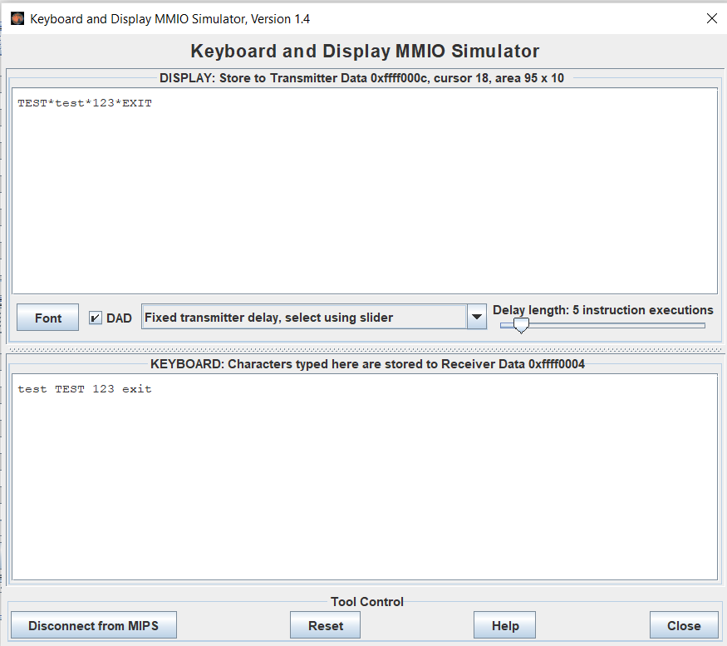

**Assignment 3**

* **Code:**

.eqv KEY_CODE 0xffff0004 # ASCII tu ban phim, 1 byte

.eqv KEY_READY 0xffff0000 # =1 neu ma co ky tu moi

# tu dong clear sau lw

.eqv DISPLAY_CODE 0xffff000c # ASCII de show, 1 byte

.eqv DISPLAY_READY 0xffff0008 # = 1 neu ma san sang ghi, clear sau sw

.eqv HEADING 0xffff8010 # Integer: Goc quay tu 0 den 359

# 0 : Tren

# 90: Phai

# 180: Duoi

# 270: Trai

.eqv MOVING 0xffff8050 # Boolean: Co di chuyen hay khong

.eqv LEAVETRACK 0xffff8020 # Boolean (0 hoac !0):

# Co track hay khong

.eqv WHEREX 0xffff8030 # Integer: Doc gia tri X hien tai cua con bot

.eqv WHEREY 0xffff8040 # Integer: Doc gia tri Y hien tai cua con bot

.text

li $a2, KEY_CODE

li $a3, KEY_READY

li $s0, DISPLAY_CODE

li $s1, DISPLAY_READY

li $t8, 0 # Check xem co dang chay hay khong

li $t3, 32 # dau cach

li $t4, 119 # w

li $t5, 97 # a

li $t6, 115 # s

li $t7, 100 # d

loop:

nop

WaitForKey:

lw $t1, ($a3) # t1 = [k1] = KEY_READY

beq $t1, $0, WaitForKey # key == 0 => wait

ReadKey:

lw $t0, 0($a2) # Doc ky tu

WaitForDis:

lw $t2, ($s1)

beq $t2, $0, WaitForDis

ShowKey:

sw $t0, ($s0)

beq $t0, $t4, UP

beq $t0, $t5, LEFT

beq $t0, $t6, DOWN

beq $t0, $t7, RIGHT

beq $t0, $t3, RUN_STOP # space

next:

nop

j loop

UP:

addi $a0, $0, 0

jal ROTATE

j next

LEFT:

addi $a0, $0, 270

jal ROTATE

j next

DOWN:

addi $a0, $0, 180

jal ROTATE

j next

RIGHT:

addi $a0, $0, 90

jal ROTATE

j next

RUN_STOP:

beq $t8, $0, RUN

jal STOP

addi $t8, $0, 0

j next

RUN:

jal GO

addi $a0, $0, 90

jal ROTATE

addi $t8, $0, 1

j next

GO:

li $at, MOVING # Thay doi cong MOVING

addi $k0, $0, 1 # logic 1

sb $k0, ($at) # Bat dau chay

jr $ra

STOP:

li $at, MOVING # Thay doi cong MOVING

sb $0, ($at) # Dung chay

jr $ra

TRACK:

li $at, LEAVETRACK # Thay doi cong LEAVETRACK

addi $k0, $0, 1 # logic 1

sb $k0, 0($at) # bat dau tracking

jr $ra

UNTRACK:

li $at, LEAVETRACK # Thay doi cong LEAVETRACK

sb $0, 0($at) # dung ve

jr $ra

ROTATE:

li $at, HEADING # Thay doi cong HEAD

sw $a0, ($at) # Xoay robot

jr $ra

* **Kết quả**

